Scenario #6: Configure Genre Characteristics via Admin page on YMD

# Description

This test scenario covers a user attempting to configure a genre

The test scenario covers a user applying further configurations to a genre

* Blacklist a Genre - is which genres you want to hide any games that are part of that genre
* Hidden Genres - hidden is just hiding those genres themselves
* Evaluates overall user experience of browsing to the configuration page once signed in and saving the selected preferences.

# Test Scripts

The following scripts will cover this scenario:

* 6.1. Blacklisted Genre
* 6.2. Hidden Genre
* 6.3. No Changes made / Cancel Changes
* 6.4. Changes reflected on the user settings overview via admin
* 6.5. Add Genre Characteristics

# Use Case

When User

Wants to change the Genre Configuration, and fill out the requested information

So that the User is granted an account with a specific Genre configuration where a user want to hide any games that are part of that genre or hide genres themselves

Extends use-case (Login)

# Test Components/Requirements

This test scenario covers the following high-level test requirements (see scripts below for specific requirements covered by each test script):

* Authentication
* Persistence

# User Groups

* Average user

# Script 1: Blacklisted Genre

## Description

* An unauthenticated user will visit a page of the site where the navigation bar is offered (currently all pages)
* Attempt to blacklist a genre i.e. hide any games that are part of that genre
* Observe the result - The user should then have blacklisted genre updated and saved via saving preferences and the user settings is automatically updated and the games visible to the user is less the blacklisted genres games

## Setup

* The testing user should ensure they are logged in
* The testing user should ensure that the genres they are blacklisting are not the ones that are already blacklisted or there are no blacklisted genres at all saved prior to this attempt

|  |  |  |  |  |
| --- | --- | --- | --- | --- |
| **Step #** | **Test Step** | **Expected Test Results** | **P** | **F** |
| **1.** | Visit the site | Site loads with no errors |  |  |
| **2.** | Click “Sign up” or “Sign in” in the top right | A modal window appears asking for registration details or log in details |  |  |
| **3.** | Once logged in Click “Admin” in the top right | A modal window appears providing admin over view details and options to configure Genre and Characteristics on the left hand side of the modal window as options |  |  |
| **4.** | Click “Genres” in the modal window located on left hand side presented as options | The page refreshes and the modal window displays options to black list a genre or hide a genre via ticking a box on the left hand side of genres presented as an option to the user |  |  |

|  |  |  |  |  |
| --- | --- | --- | --- | --- |
| **5.** | Select “Genres” in the modal window via a tick box located on the left hand side presented as options under blacklist genres and then Click “Save” in the modal window at the bottom of the page | The page refreshes and an information pop up shows that “Blacklisted genres have been updated” |  |  |
| **6.** | Click “On YMD home page” in the modal window while still signed in | The YMD homepage has filtered the blacklisted genres |  |  |

|  |  |
| --- | --- |
| **Field Name** | **Data** |
| Sign In / Sign Up | No change |
| Blacklist Genres | Utilities , Video Production |

|  |  |  |  |
| --- | --- | --- | --- |
| Date/Time | Tester | Test Phase | Status |
| 23/08/17 20:15 | Shailesh Jha | Alpha | Passed |

**Please refer to the screenshots below:**

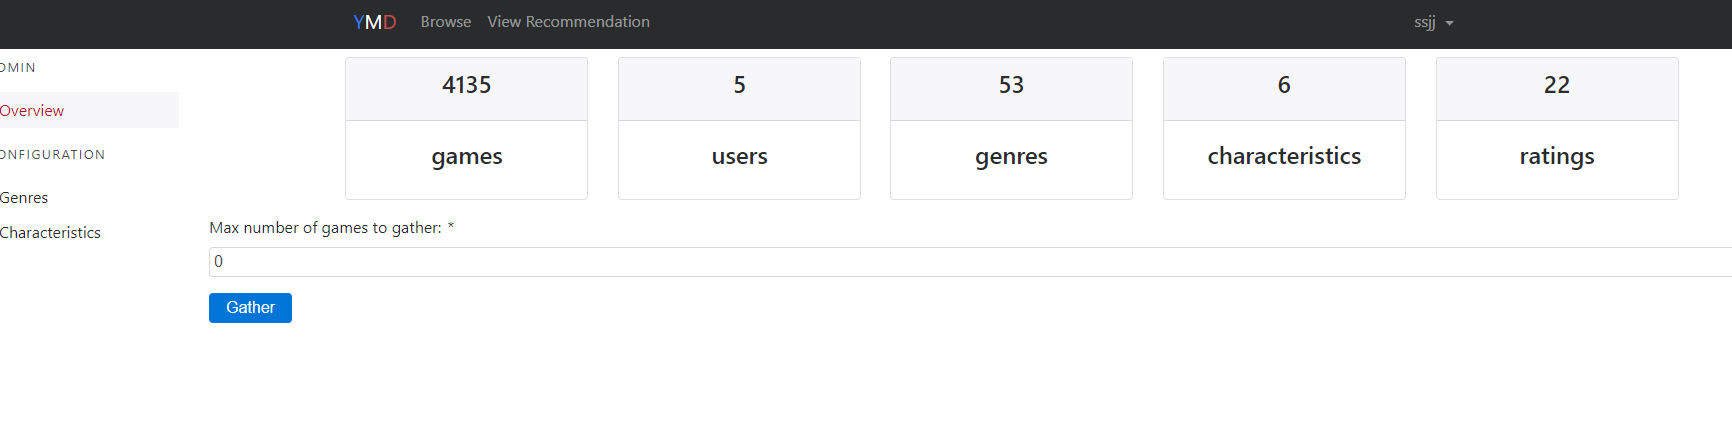

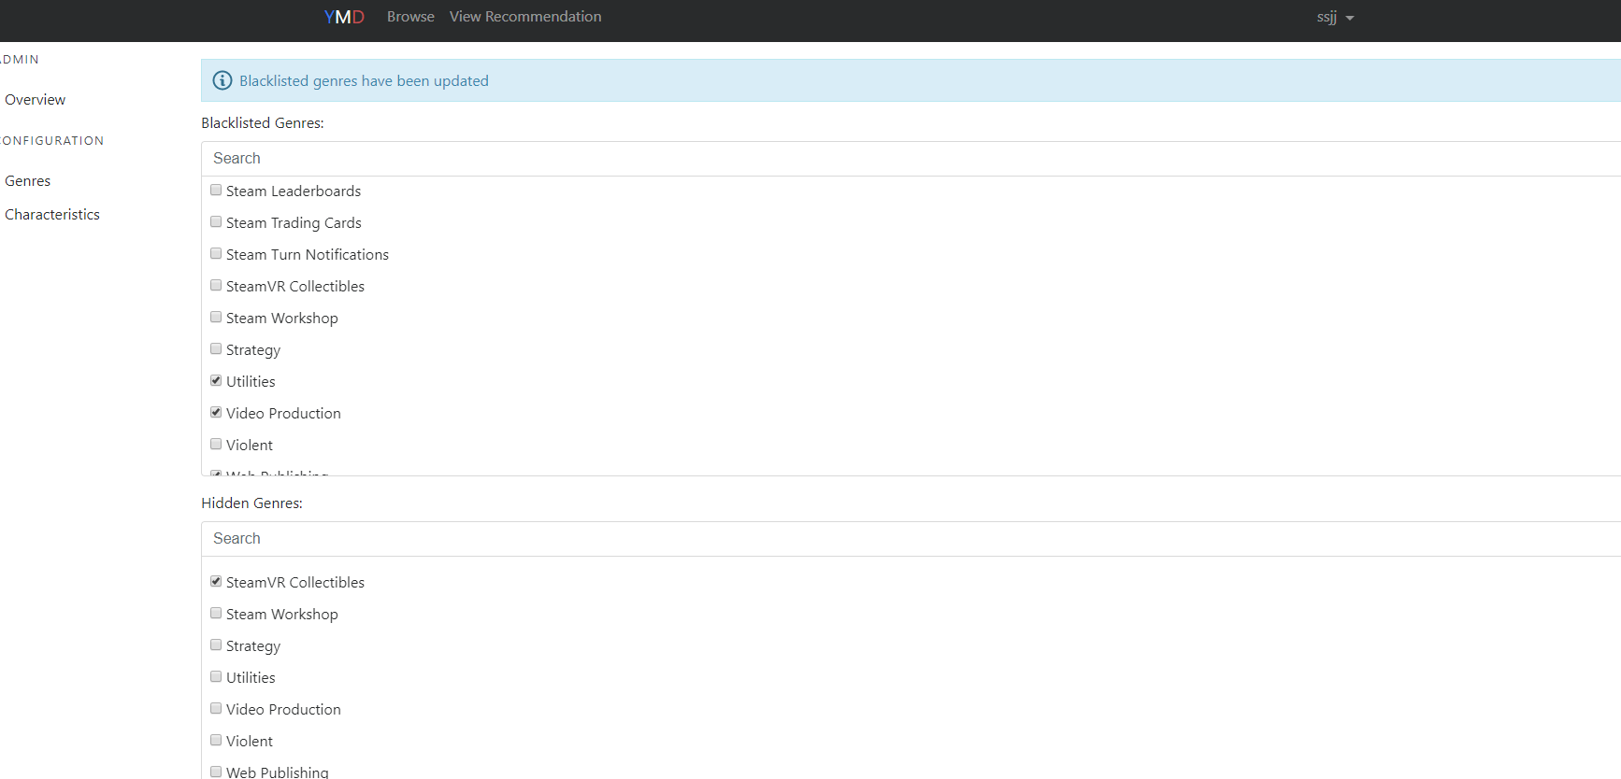

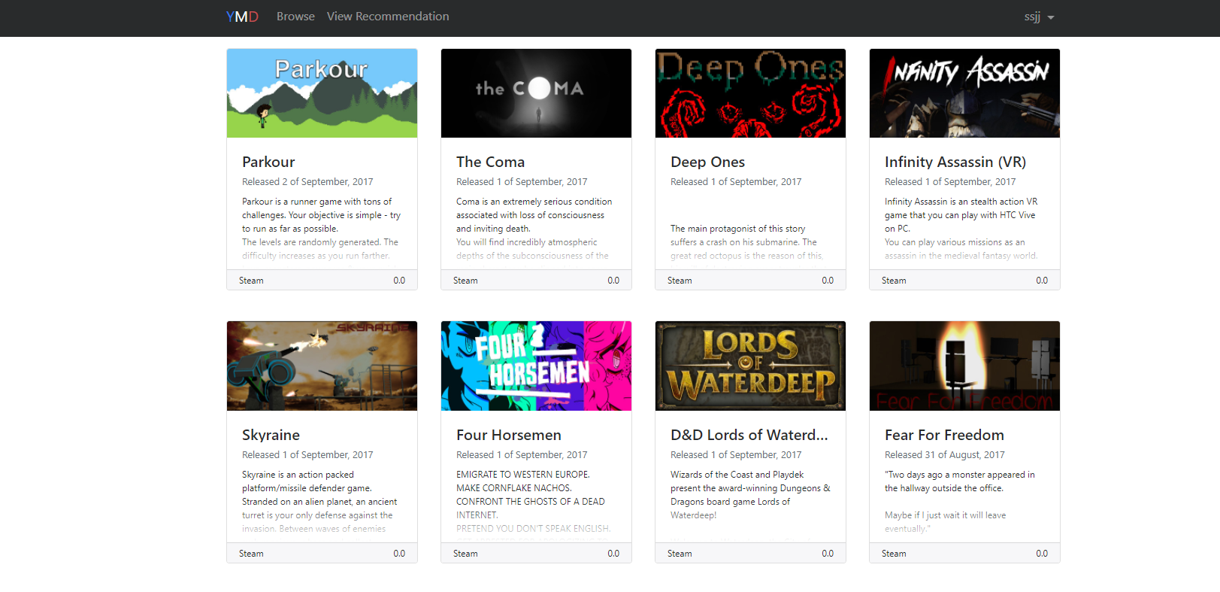

# Script 2: Hidden Genre

## Description

* An unauthenticated user will visit a page of the site where the navigation bar is offered (currently all pages)
* Attempt to hide a genre i.e. hide the genres themselves
* Observe the result - The user should then have hidden genres updated and saved via saving preferences and the user settings is automatically updated and the games visible to the user is less the hidden genres games on home page

## Setup

* The testing user should ensure they are logged in
* The testing user should ensure that the genres they are hiding are not the ones that are already hidden or there are no hidden genres at all saved prior to the attempt

|  |  |  |  |  |
| --- | --- | --- | --- | --- |
| **Step #** | **Test Step** | **Expected Test Results** | **P** | **F** |
| **1.** | Visit the site | Site loads with no errors |  |  |
| **2.** | Click “Sign up” or “Sign in” in the top right | A modal window appears asking for registration details or log in details |  |  |
| **3.** | Once logged in Click “Admin” in the top right | A modal window appears providing admin over view details and options to configure Genre and Characteristics on the left hand side of the modal window as options |  |  |
| **4.** | Click “Genres” in the modal window located on left hand side presented as options | The page refreshes and the modal window displays options to black list a genre or hide a genre via ticking a box on the left hand side of genres presented as an option to the user |  |  |

|  |  |  |  |  |
| --- | --- | --- | --- | --- |
| **5.** | Select “Genres” in the modal window via a tick box located on the left hand side presented as options under hidden genres and then Click “Save” in the modal window at the bottom of the page | The page refreshes and an information pop up shows that “blacklisted genres have been updated” |  |  |
| **6.** | Click “On YMD home page” in the modal window while still signed in | The YMD homepage has filtered the hidden genres |  |  |

|  |  |
| --- | --- |
| **Field Name** | **Data** |
| Sign In / Sign Up | No change |
| Hidden Genres | Stream VR Collectibles |

|  |  |  |  |
| --- | --- | --- | --- |
| Date/Time | Tester | Test Phase | Status |
| 23/08/17 20:45 | Shailesh Jha | Alpha | Passed |

**Please refer to the screenshots in script 1**

# Script 3: No Changes made / Cancel Changes

## Description

* An unauthenticated user will visit a page of the site where the navigation bar is offered (currently all pages)
* Attempt to black list or hide a genre and then do not save the changes
* Observe the result - The user should then be able to close browser or simply go back and without saving and have no changes reflected in admin or user settings

## Setup

* The testing user should ensure they are logged in
* The testing user should click on blacklisted and hidden genres on the configure genre page. However, should not save the preferences and leave the portal or simply close the window

|  |  |  |  |  |
| --- | --- | --- | --- | --- |
| **Step #** | **Test Step** | **Expected Test Results** | **P** | **F** |
| **1.** | Visit the site | Site loads with no errors |  |  |
| **2.** | Click “Sign up” or “Sign in” in the top right | A modal window appears asking for registration details or log in details |  |  |
| **3.** | Once logged in Click “Admin” in the top right | A modal window appears providing admin over view details and options to configure Genre and Characteristics on the left hand side of the modal window as options |  |  |
| **4.** | Click “Genres” in the modal window located on left hand side presented as options | The page refreshes and the modal window displays options to black list a genre or hide a genre via ticking a box on the left hand side of genres presented as an option to the user |  |  |

|  |  |  |  |  |
| --- | --- | --- | --- | --- |
| **5.** | Select “Genres” in the modal window via a tick box located on the left hand side presented as options under blacklist and hidden genres and then DO NOT Click “Save” in the modal window at the bottom of the page instead close the window or click the back button. Sign back in. | There are no updates made to the user settings or to the admin details |  |  |
| **6.** | Click “On YMD home page” in the modal window while still signed in | No changes have been made to the games that are displayed to the user |  |  |

|  |  |
| --- | --- |
| **Field Name** | **Data** |
| Sign In / Sign Up | No change |
| Blacklisted Genres | Sports, Stats |
| Hidden Genres | Action, Adventure |

|  |  |  |  |
| --- | --- | --- | --- |
| Date/Time | Tester | Test Phase | Status |
| 23/08/17 21:15 | Shailesh Jha | Alpha | Passed |

**Please refer to the screenshots below:**

**UNSAVED Changes**

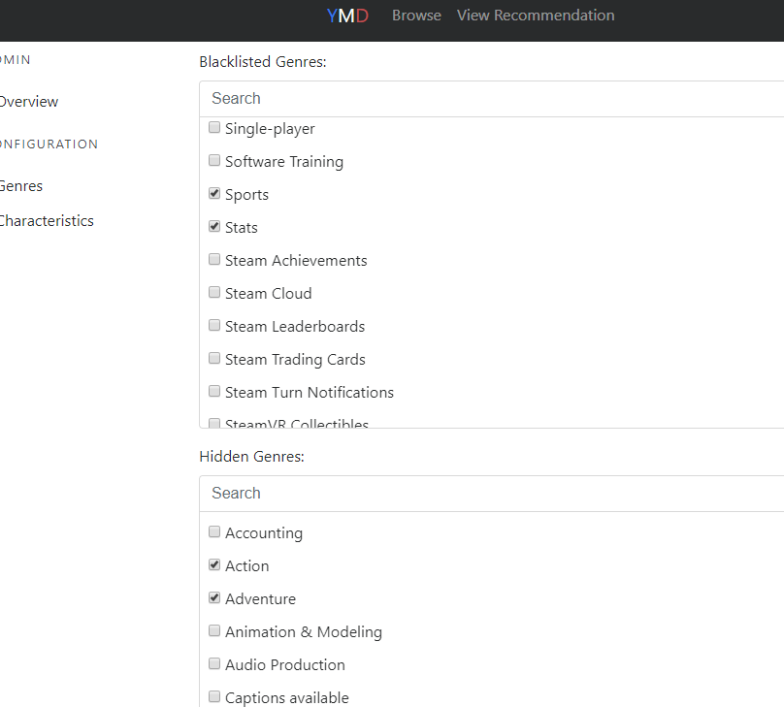

**NO CHANGES Recorded or confirmed upon viewing the home page**

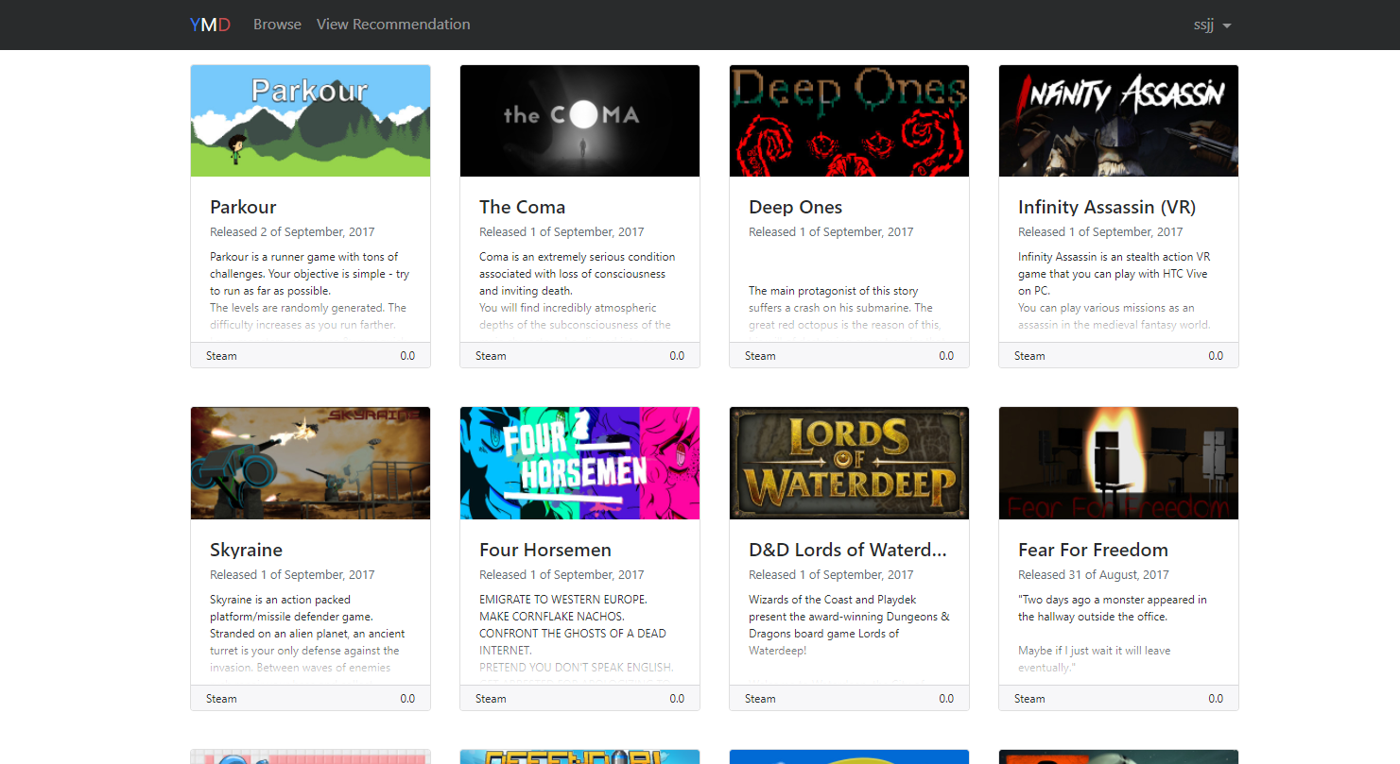

# Script 4: Changes reflected on the user settings overview via admin

## Description

* An unauthenticated user will visit a page of the site where the navigation bar is offered (currently all pages)
* Attempt to black list or hide a genre and then save the changes
* Observe the result - The user should then be able to see the changes made and the current configuration i.e. after the change via the admin overview located on the left hand side of the modal window

## Setup

* The testing user should ensure they are logged in
* The testing user should click on blacklisted and hidden genres on the configure genre page selecting the black

|  |  |  |  |  |
| --- | --- | --- | --- | --- |
| **Step #** | **Test Step** | **Expected Test Results** | **P** | **F** |
| **1.** | Visit the site | Site loads with no errors |  |  |
| **2.** | Click “Sign up” or “Sign in” in the top right | A modal window appears asking for registration details or log in details |  |  |
| **3.** | Once logged in Click “Admin” in the top right | A modal window appears providing admin over view details and options to configure Genre and Characteristics on the left hand side of the modal window as options |  |  |
| **4.** | Click “Genres” in the modal window located on left hand side presented as options | The page refreshes and the modal window displays options to black list a genre and hide a genre via ticking a box on the left hand side of genres presented as an option to the user |  |  |

|  |  |  |  |  |
| --- | --- | --- | --- | --- |
| **5.** | Select “Genres” in the modal window via a tick box located on the left hand side presented as options under blacklist and hidden genres and then Click “Save” in the modal window at the bottom of the page | The page refreshes and an information pop up shows that “blacklisted genres have been updated” |  |  |
| **6.** | Click “On Overview “in the modal window while still signed in located on the left hand side of admin page | Changes have been recorded under admin overview indicated via increase or decrease in number of hidden, blacklisted and added categories. |  |  |

|  |  |
| --- | --- |
| **Field Name** | **Data** |
| Sign In / Sign Up | No change |
| Blacklisted Genres | Sports, Stats |
| Hidden Genres | Action, Adventure |

|  |  |  |  |
| --- | --- | --- | --- |
| Date/Time | Tester | Test Phase | Status |
| 23/08/17 21:37 | Shailesh Jha | Alpha | Passed |

**Please refer to the before after screenshots**

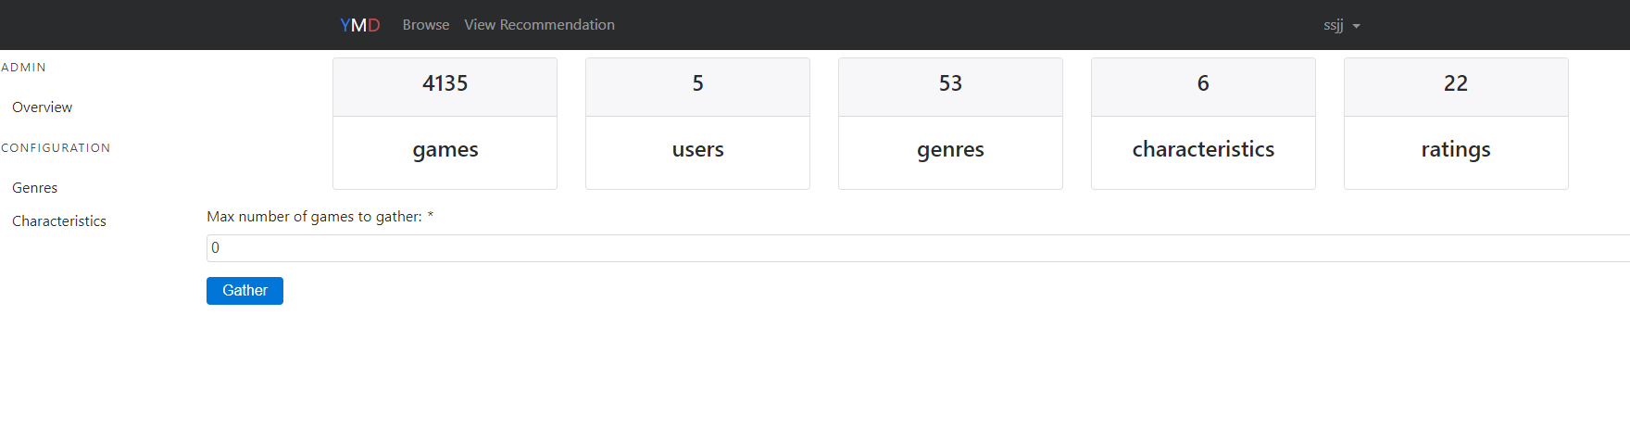

# 

# Script 5: Configure Characteristics

## Description

* An unauthenticated user will visit a page of the site where the navigation bar is offered (currently all pages)
* Attempt to add characteristic once on the admin page via configure characteristic
* Observe the result - The user should then be able to see the changes made and the current configuration i.e. after the change via the admin overview located on the left hand side of the modal window

## Setup

* The testing user should ensure they are logged in
* The testing user should add characteristic and visit admin overview page upon saving

|  |  |  |  |  |
| --- | --- | --- | --- | --- |
| **Step #** | **Test Step** | **Expected Test Results** | **P** | **F** |
| **1.** | Visit the site | Site loads with no errors |  |  |
| **2.** | Click “Sign up” or “Sign in” in the top right | A modal window appears asking for registration details or log in details |  |  |
| **3.** | Once logged in Click “Admin” in the top right | A modal window appears providing admin over view details and options to configure Genre and Characteristics on the left hand side of the modal window as options |  |  |
| **4.** | Click “Characteristics” in the modal window located on left hand side presented as options | The page refreshes and the modal window displays options to add characteristics against each listed genre via a text box located on the right hand side of each listed genre |  |  |

|  |  |  |  |  |
| --- | --- | --- | --- | --- |
| **5.** | Add Characteristic to any of the preferred genre by simply typing in the text box next to a genre | The page refreshes and an information pop up shows that “Saved characteristics” |  |  |
| **6.** | Click “On Overview “in the modal window while still signed in located on the left hand side of admin page | Changes have been recorded under admin overview indicated via increase in number of characteristics |  |  |

|  |  |
| --- | --- |
| **Field Name** | **Data** |
| Sign In / Sign Up | No change |
| Selected Genres | Sports, Stats |
| Added Characteristics Data | Fun, Hate |

|  |  |  |  |
| --- | --- | --- | --- |
| Date/Time | Tester | Test Phase | Status |
| 23/08/17 22:45 | Shailesh Jha | Apha | Passed |

**Please refer to the before after screenshots**

# 

After updating characteristics:

